Progress check Unit 1

- Match colunms.
Тётя соusin
Дядя nephew
Сестра twins
племянник pet
племянница niece
близнецы aunt
питомец uncle
кузен sister

- Write down figures.
- twenty -six
- thirty- five
-sixty-eight
-ninety- four
-fifty
Seventy-seven
A hundred

3.Answer the questions about your desk with It is / They are and the prepositions in / on / under / next to.
- Where are your pens? ______________________________________________________
- Where are your books? ______________________________________________________
- Where is your bag? _______________________________________________________
- Where is your pencil case? _______________________________________________________
- Where is your homework? _______________________________________________________
- Where are your pencils? _______________________________________________________

4.Look at the map. Make sentences with There is a… / There isn’t a … and There are… / There aren’t any… .

Example: There are two supermarkets.
supermarket beach hotel park restaurants cinema
bus station swimming pool stadium

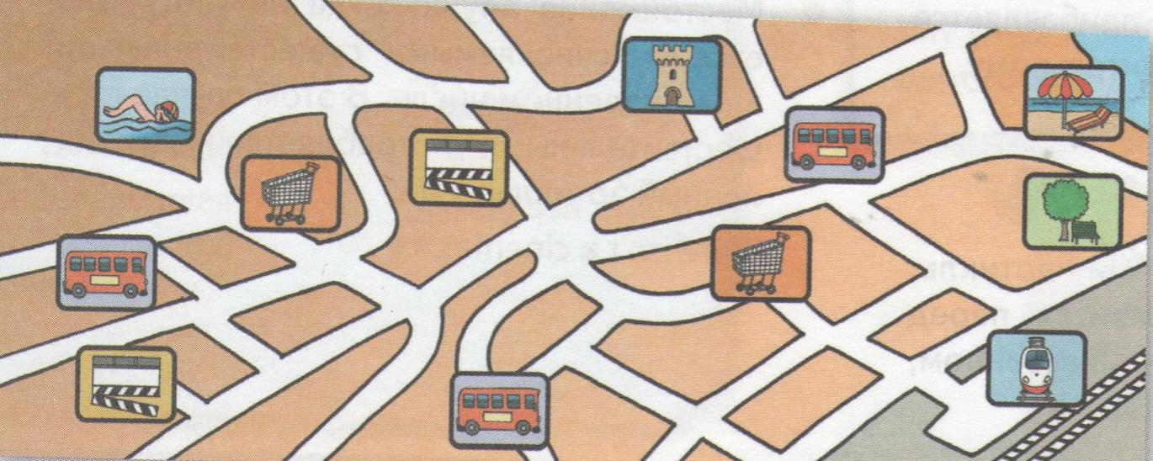
1._________________________________________________________________
2._________________________________________________________________

